Machine Learning Overview - Linear Regression

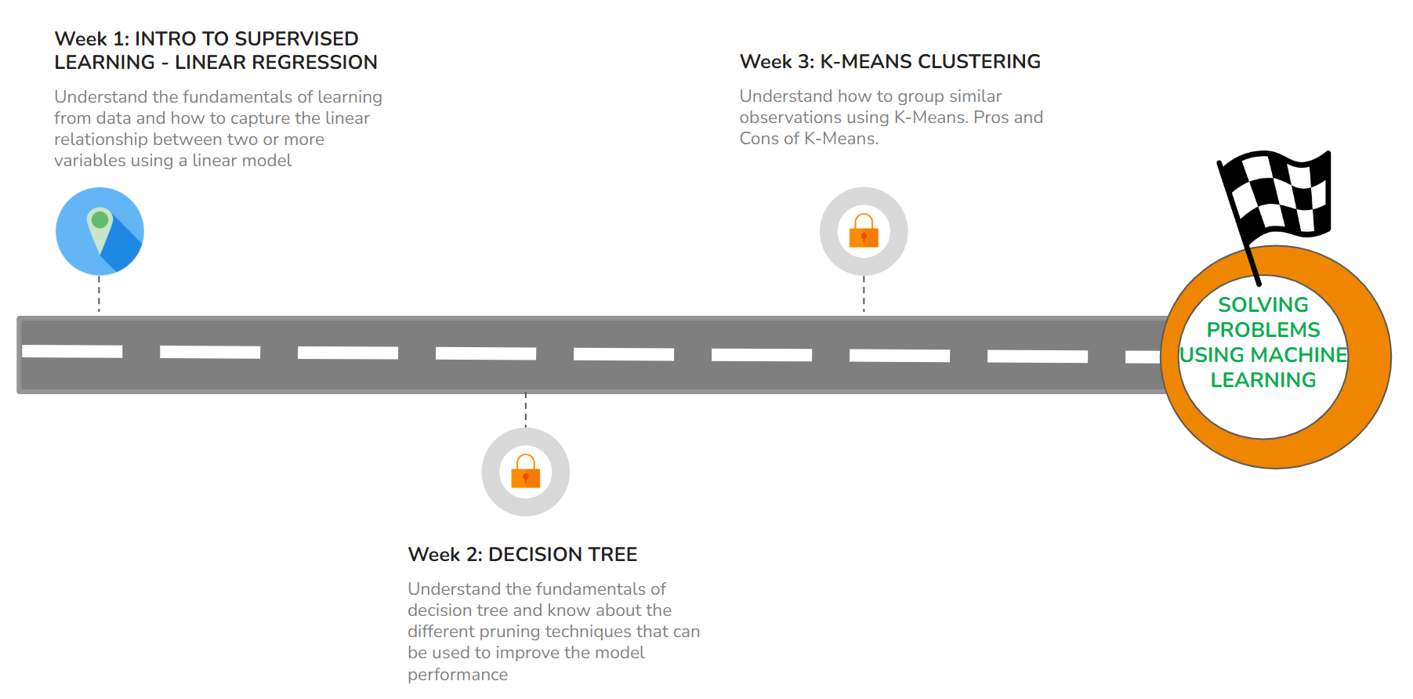
WEEK 1 OVERVIEW
This week, we will learn about linear relationships and how to model the linear relationship between two or more variables. The following topics will be covered in this week:
- Business Problem and Solution Space - Regression
- Correlation and Linear Relationships
- Simple and Multiple Linear Regression
- Categorical Variables in Linear Regression
- Regression Metrics

LEARNING INSTRUMENTS

Week | Module | No. of Videos | Total Duration | No. of Test Your Understanding Quizzes | No. of Graded Quizzes
1 | Linear Regression - Theory | 14 | ~2.5 hours | 10 | 1
1 | Linear Regression - Hands-on | 8 | 1-2 hours | 8 | 0

IMPORTANT NOTES
As this week will cover Linear Regression as well as hands-on implementation of the same using Python, kindly note the following points:
- The hands-on videos are elaborate and cover the code in detail, and the hands-on notebook provided has detailed comments explaining the functioning of the code.
- The videos 1.15 Data Overview - Hands-on and 1.16 EDA - Hands-on cover data overview and EDA in detail. Since these topics have been covered in detail before, you can feel free to watch the videos at a faster pace and/or skip these videos at your convenience.
- In case you are comfortable with coding in Python, you can feel free to watch the rest of the hands-on videos at a faster pace at your convenience by covering the hands-on notebook with detailed commentary.
- It is recommended to spend at least 1.5 hours/day along with practicing datasets and quizzes.

